Spiral Model

**Introduction:**

The spiral model combines the idea of iterative development with the systematic, controlled aspects of the waterfall model. This Spiral model is a combination of iterative development process model and sequential linear development model

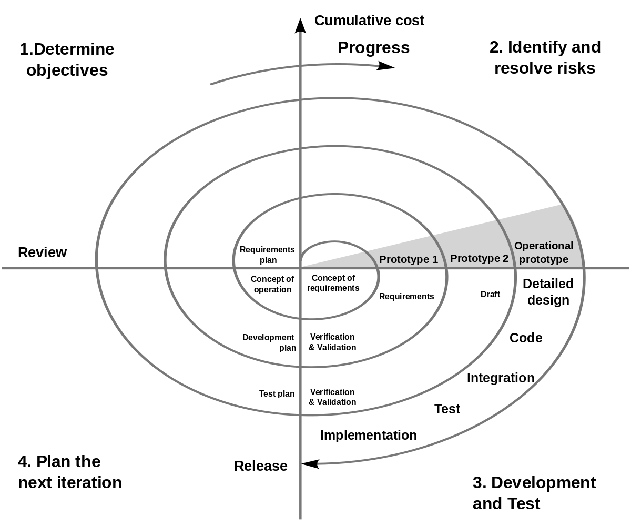i.e. the waterfall model with a very high emphasis on risk analysis. It allows incremental releases of the product or incremental reﬁnement through each iteration around the spiral.

# Problem Statement:

The Baby Toy Company was selling premium toys but the business had been stagnant over the years. They are looking at bringing in new offerings to increase revenue. A survey was conducted on kids and their preference for toys and it was found that attention span/engagement with a new toy lasts only few days for kids and they start demanding a new one within a week. However, the survey also brought out that parents found affording premium toys diﬃcult. Like any business, they saw an opportunity here and decided to launch a new offering of premium toys being available on rent and directed the IT team to make rental option for customers available on their online.

# Purpose:

Launching a new offering of premium toys on rent and implementing rental options for customers available online.

**Description:**

* 1. Module 1: **Advertising Module**

It is about advertising new toys coming to market. The 1st week is for posting a banner of the new toys which will be available, in next week we can post about the new features of the toy and from when it will be available.

* 1. Module 2: **Renting Module**

This module will facilitate the parents to buy new toys for their children on rent by providing all the necessary options to the parents.Necessary options include delivery address, payment details and the warranty conditions.

* 1. Module 3: **Return Module**

In this module the parents are able to return the toy after the speciﬁed renting period.The parents will also be given an option to extend the renting period.

# Advantages of Spiral Model:

* + - Software is produced early in the software life cycle.
    - Risk handling is one of the important advantages of the Spiral model.
    - Flexibility in requirements. In this model, we can easily change requirements at later phases and can be incorporated accurately.
    - It is good for large and complex projects.

# Disadvantages of Spiral Model:

* It is not suitable for small projects as it is expensive.
* It is much more complex than other SDLC models. Process is complex.
* Too much dependable on Risk Analysis and requires highly speciﬁc expertise.
* Diﬃculty in time management. As the number of phases is unknown at the start of the project, so time estimation is very diﬃcult.